

By email only

Our Ref: 2014-233

14th March 2014

Wynyard Park

Deerness Fencing and Landscaping Ltd.
Esh House.
Bowburn North Industrial Estate.
Bowburn
Durham
DH6 5PF
Tel: 0191 377 4630
Fax: 0191 377 4631

For the attention of: Joseph Musgrave

Dear Matt

RE: Path Works – Wynyard Park

Further to your recent request regarding landscaping works at the above site, we are pleased to quote as follows:-

To remove 6 m2 of shrubbery; excavate soil to 100mm depth (soil to remain on site).
Supply and install 8 L/M board edging with pegs at 1 metre centres.
Lay membrane and fill with bark mulch. (To match existing, see picture below).

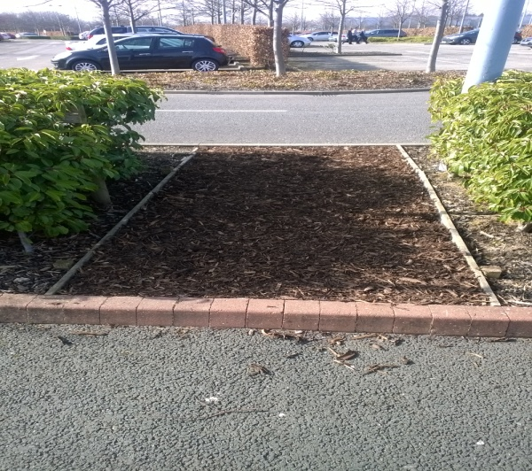

ITEM £100.00

- Subject to VAT at the current rate
- Open for acceptance for TWO weeks
- Price Fixed until 30/11/14

We trust our offer meets with your approval. Assuring you of our best attention at all times.

Yours faithfully

Paul Crowe
Operations Director - Landscaping

